**2025-2026 Third Grade Supply List**

* 4 Composition Notebooks
* 2 folders- one labeled take home (durable, 2 pocket) and one red folder labeled unfinished work
* Supply box/case
* Scissors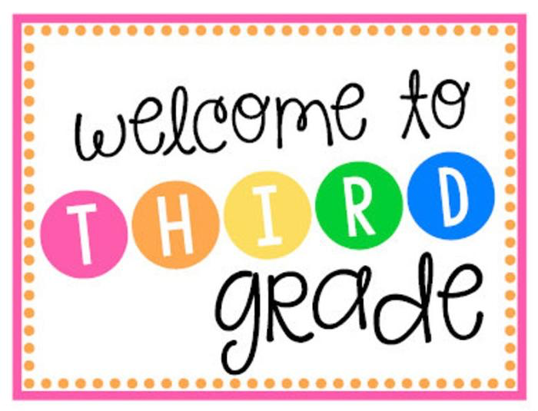
* Ruler
* 1 box of crayons- 24 count
* 1 box of colored pencils- 12 count
* 1 box of markers- 10 count
* 1 pack of Expo markers
* 1 pencil sharpener
* 1 pack of erasers
* 1 package of construction paper
* 2 paper towel rolls
* 3 packs of glue sticks
* 3 boxes of sharpened pencils- #2
* 4 boxes of tissues
* Lysol Disinfectant Spray
* Hand sanitizer to keep in desk
* Earbuds in a case or ziploc bag (Please label with name)
* Novels: **Charlotte's Web by E.B. White**

*Assignment pad- purchased at school

**2025-2026 Third Grade Supplies Schedule**

**1st Day of School-**

* Composition Notebooks
* Folders
* Supply box/case
* Crayons, colored pencils, markers
* Pencils
* Pencil sharpener
* Eraser
* Tissues

**2nd Day of School-**

* Wonders Practice Book, Reading & Writing Companion Books, Literature Anthology
* Construction paper
* Glue sticks
* Scissors
* Ruler
* Expo markers

**3rd Day of School-**

* Envision Math Workbooks and Additional Practice book
* Paper towels
* Lysol Disinfectant Spray
* Hand sanitizer
* Earbuds in a labeled case or ziploc bag
* Novels: Charlotte's Web by E.B. White

**4th Day of School-**

*Please bring in any remaining supplies and textbooks (Science, S.S., Religion).